CaseManagement_CreationOfCase_Instance23_06-Aug-2018_03-33-13_AM_SingleSignOn.png

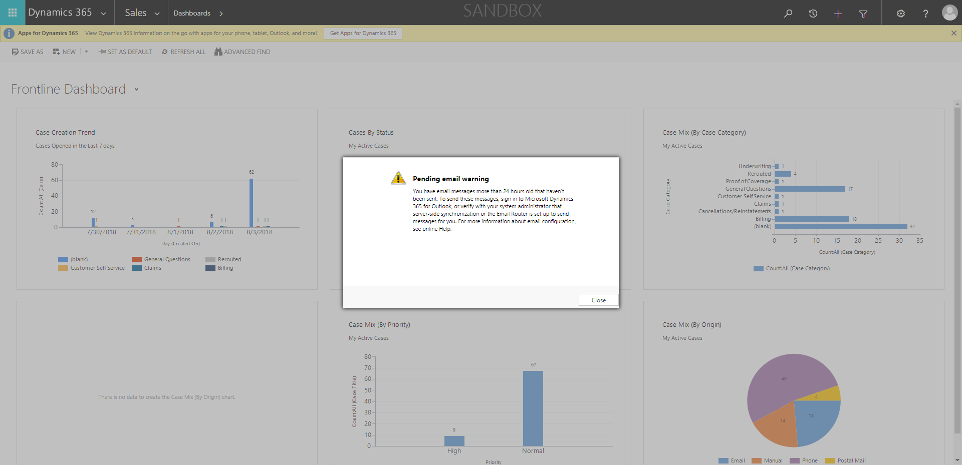

CaseManagement_CreationOfCase_Instance23_06-Aug-2018_03-33-19_AM_MouseClickActionMoveToElementBycssSelectorspanTabSFA.png

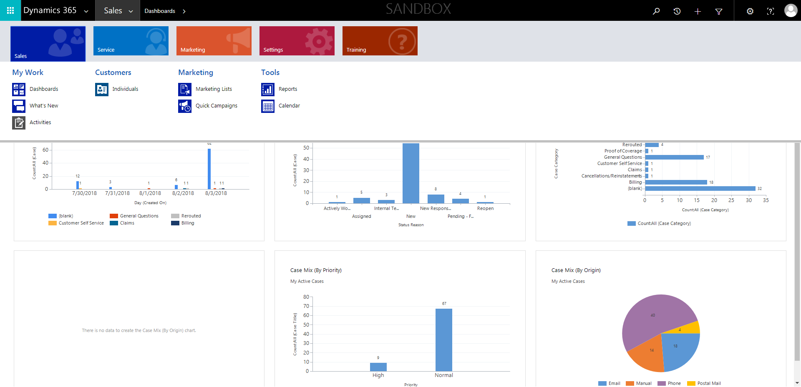

CaseManagement_CreationOfCase_Instance23_06-Aug-2018_03-32-49_AM_MouseClickActiononStaleElement.png

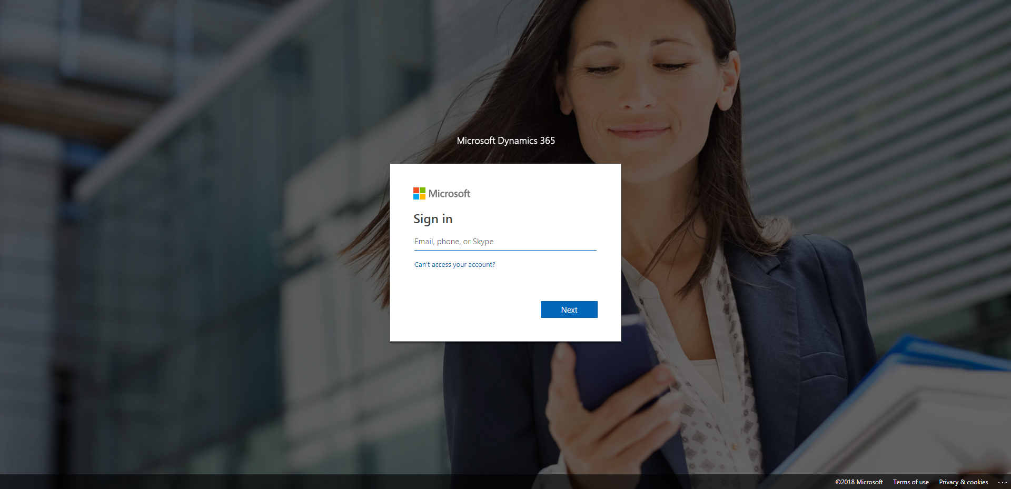

CaseManagement_CreationOfCase_Instance23_06-Aug-2018_03-33-16_AM_SingleSignOn.png

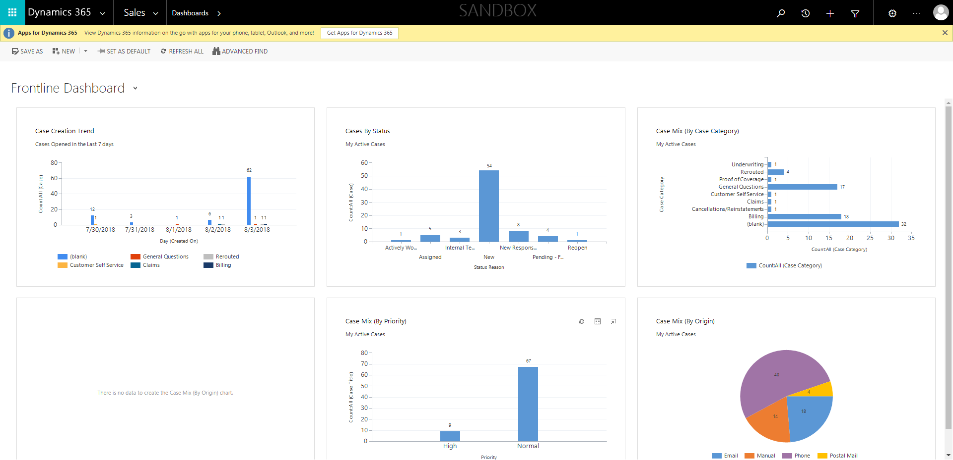

CaseManagement_CreationOfCase_Instance23_06-Aug-2018_03-33-22_AM_MouseClickActionMoveToElementBycssSelectoranavcases.png

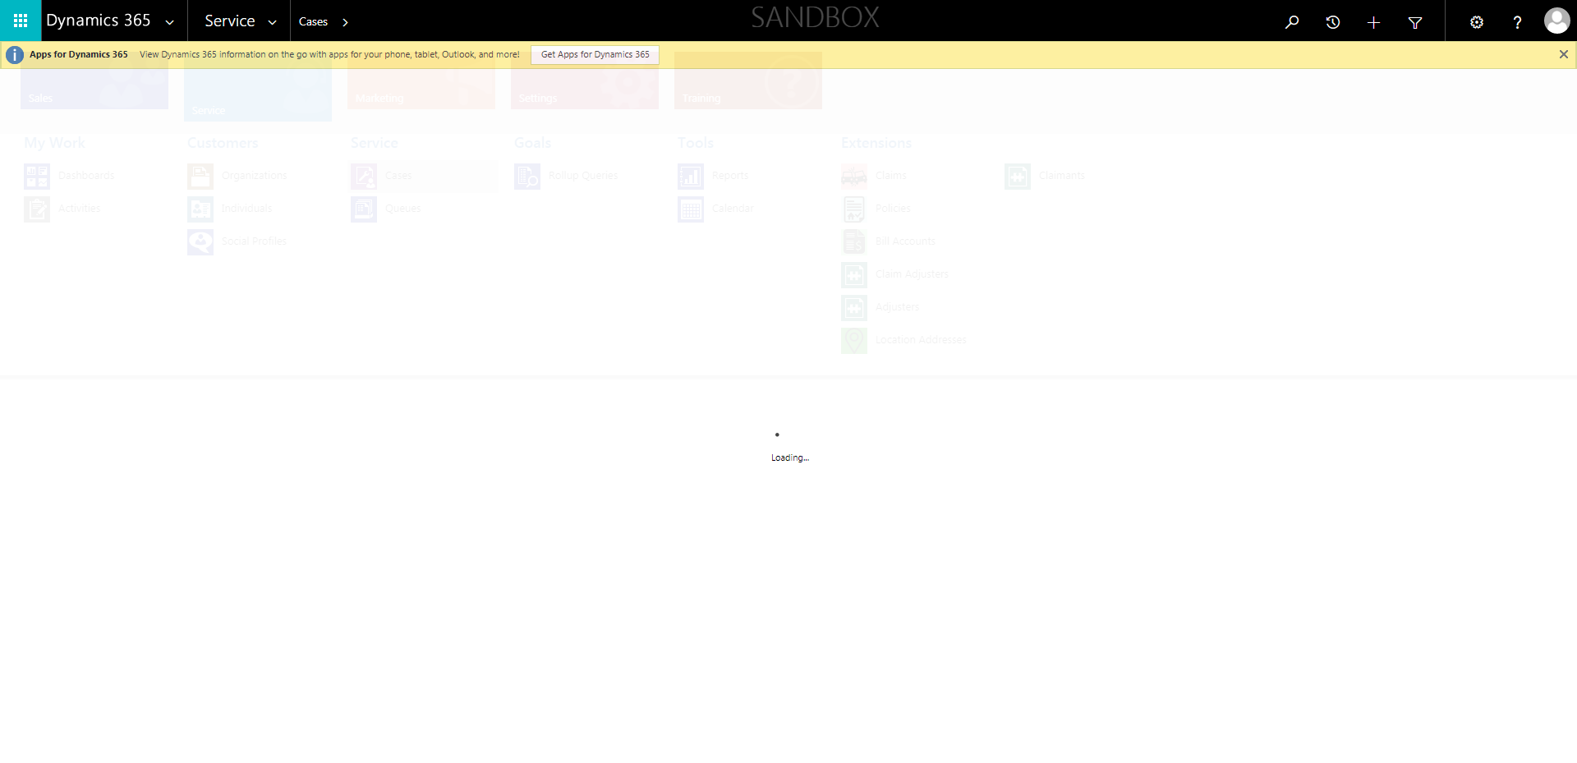

CaseManagement_CreationOfCase_Instance23_06-Aug-2018_03-32-51_AM_EnterTextAction.png

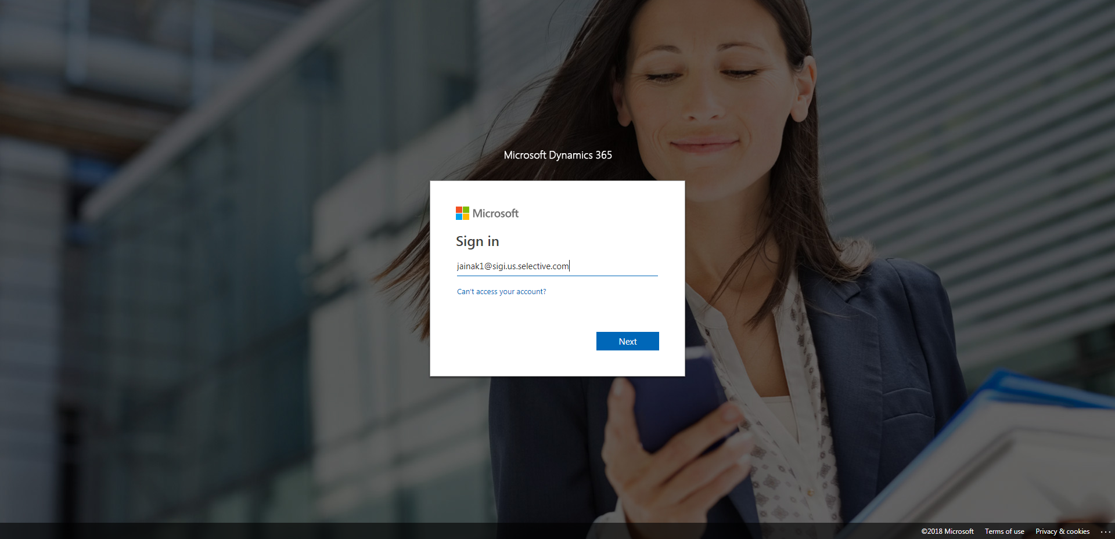

CaseManagement_CreationOfCase_Instance23_06-Aug-2018_03-33-35_AM_MouseClickActionMoveToElementBycssSelectorspanTabCS.png

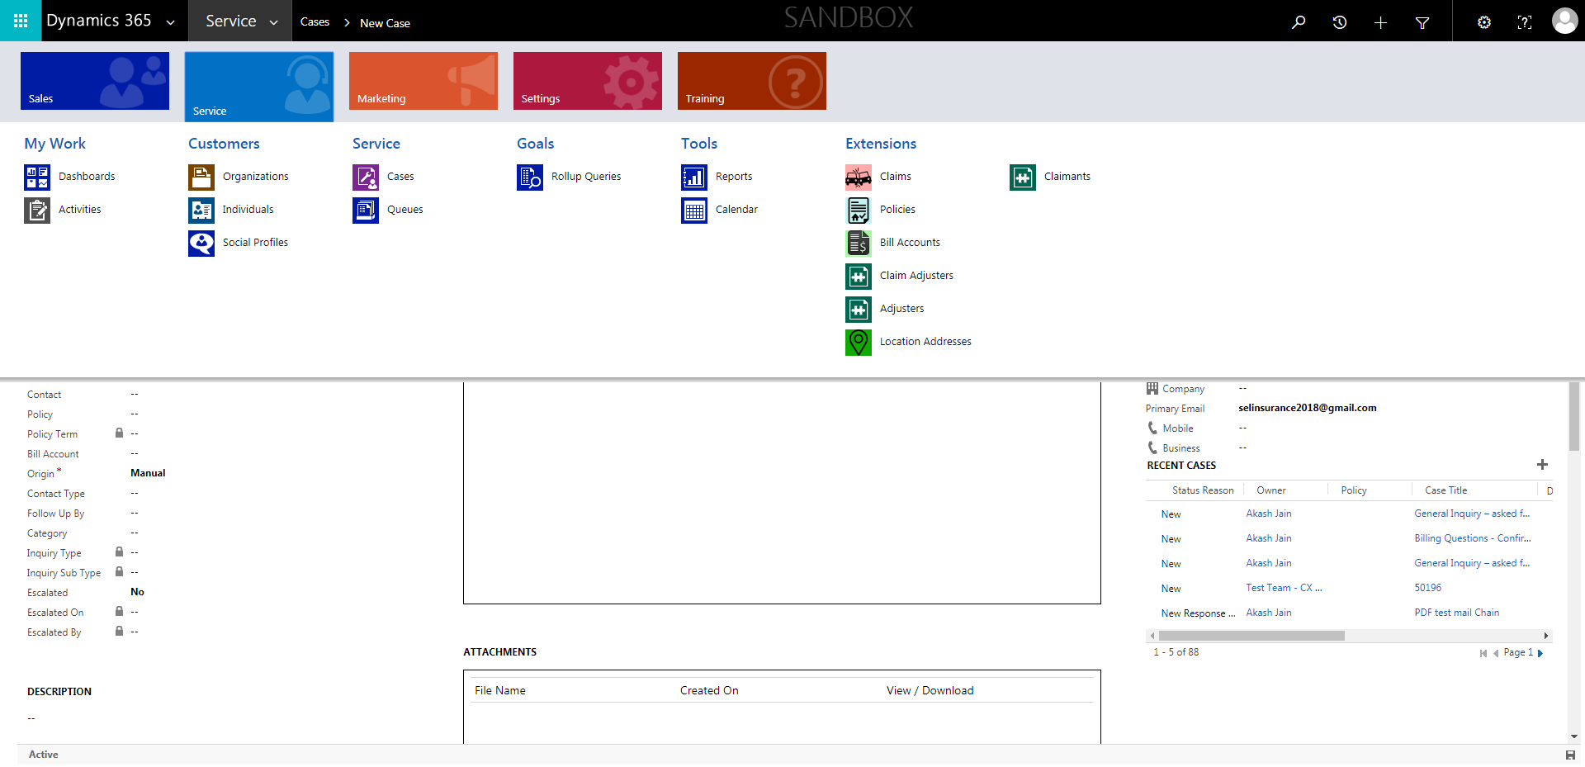

CaseManagement_CreationOfCase_Instance23_06-Aug-2018_03-33-36_AM_MouseClickActionMoveToElementByxpathimgaltServiceparentspan.png

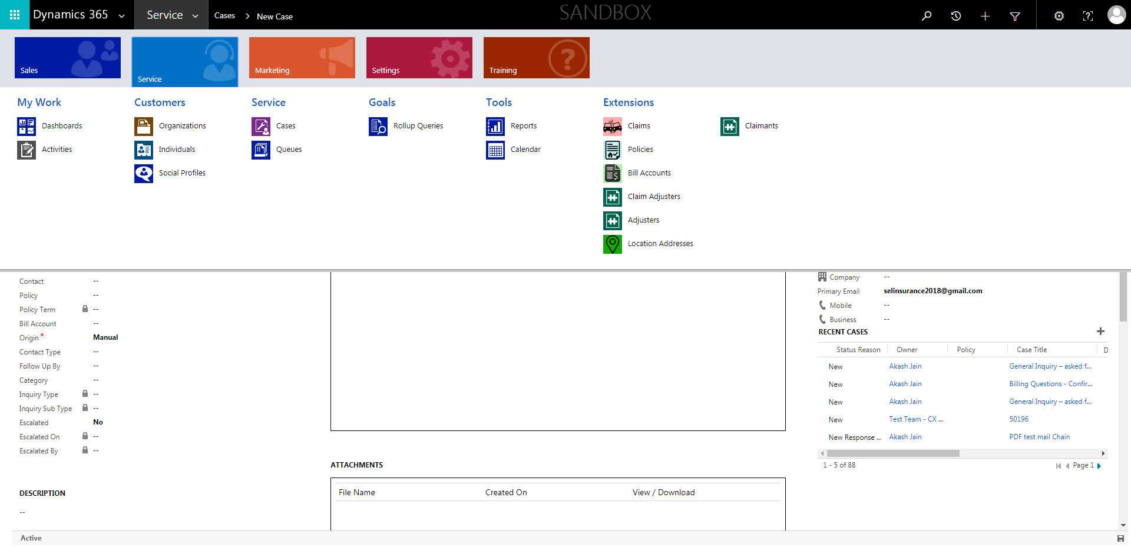

CaseManagement_CreationOfCase_Instance23_06-Aug-2018_03-33-21_AM_MouseClickActionMoveToElementByxpathimgaltServiceparentspan.png

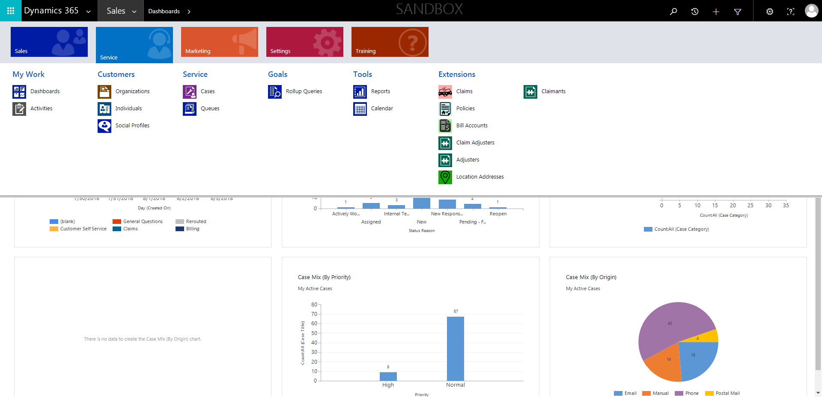

CaseManagement_CreationOfCase_Instance23_06-Aug-2018_03-32-52_AM_MouseClickActiononStaleElement.png

